**Name: __________________________________________ Date: _______________________**

# **Homework 2 – Angles, Perimeter & Area**

(Please use separate sheets of paper to show your work)

1. In the given figure, if the angle ∠a is 52 degree, then find the other seven angles.

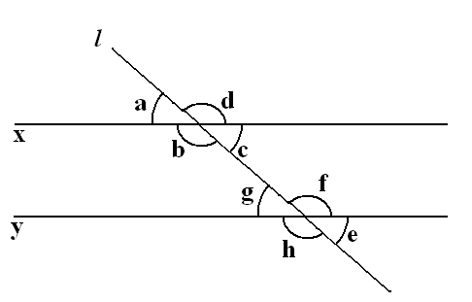

1. The figure below is missing a measurement for one line segment. What is the missing measurement?

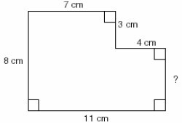

1. If the perimeter of a rectangle is 24 inches and the length of the rectangle is 3 inches, what is the width of the rectangle in inches?
2. Assuming all angles are right angles, what is the area of the polygon?

What is the perimeter of the polygon?



1. The figure below is composed of a square and a regular hexagon. If the area of the square is 25, what is the perimeter of the entire figure?



1. A rectangle’s long side is five more than twice the length of the shorter side. If the perimeter is 100, what is the length of the longest side?
2. The square shown is divided into 4 congruent rectangles. Each of them has perimeter 30 cm. What is the perimeter of the square?

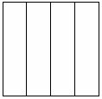

**Bonus Problems**

1. A triangle has an area of 42 square meters and a base length of 7 meters.  What is the height of the triangle?

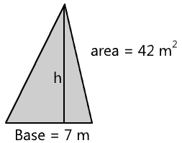

1. Find the area of this triangle. Assume that each of the small squares have an area of one square unit.



1. Find the area of the shaded part of this figure.

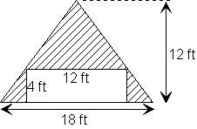

**SOLUTIONS TO HOMEWORK 2**

***Note:*** *There are many acceptable strategies to solving each problem. This sheet shows just one strategy.*

1. Given that ∠a = 52 degree and ∠g and ∠a are corresponding angles. So, ∠a and ∠g are equal. Therefore ∠g = 52 degree.

We know that a straight angle has a measure of 180 degree. So, ∠a +∠d = 180 degree.

52 +∠d = 180

∠d = 180 - 52

∠**d = 128**

Here, ∠ d and ∠ f are corresponding angles. Therefore, ∠d an*d* ∠f are equal. Therefore, ∠f is also 128 degree.

We know that, a straight angle has a measure of 180 degree. So, ∠a +∠b = 180 degree.

52 + ∠b = 180

∠b = 180 - 52

∠**b = 128**

Here, ∠b and ∠h are corresponding angles. Therefore, ∠b and ∠h are equal. Therefore, ∠h is also 128 degree.

We know that a straight angle has a measure of 180 degree. So, ∠b + ∠c = 180 degree.

128 + ∠c = 180

∠c = 180 - 128

∠**c = 52**

Here, ∠c and ∠e are corresponding angles. Therefore, ∠c and ∠e are equal. Therefore, ∠c is also 52 degree.

Therefore, ∠**a =** ∠**g =** ∠**c =** ∠**e = 52 degree.**

∠**b =** ∠**h =** ∠**d =** ∠**f = 128 degree.**

1. Since everything is right angles, looking at just the vertical measurements shown, the missing side is 8 – 3 = 5

**Answer: 5 cm.**

1. If the perimeter is 24 inches, then the sum of one length + one width is half of that, or 12 inches.

Since the length is 3 inches, the width must be 9 inches.

9 in.

3 in.

1. **Area = 448 square units**

Draw a large rectangle that perfectly encompasses the polygon, and fill in the missing dimensions by adding or subtracting the other dimensions:

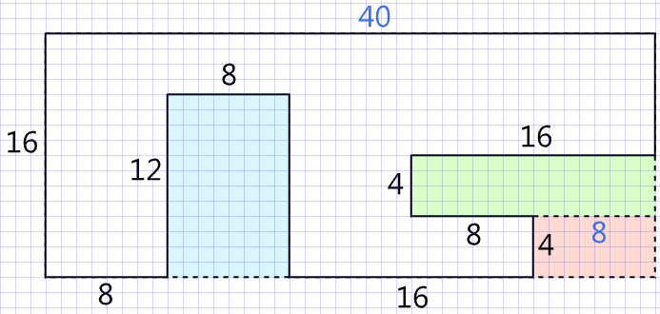

Now, take the area of the large encompassing rectangle, and subtract the areas of the three smaller rectangles (blue, green, and red) that have been “carved out” of the large rectangle.

Area of large rectangle = 40 × 16 = 640

Area of blue rectangle = 8 × 12 = 96

Area of green rectangle = 16 × 4 = 64

Area of red rectangle = 8 × 4 = 32

So, the area of the white polygon is 640 – 96 – 64 – 32 = 448 square units.

**Perimeter = 16+8+12+8+12+16+4+8+4+16+8+40 = 152**

1. **40**

If the area of the square is 25, then the length of its side must be 5. The length of the side of the hexagon is the same as the length of the side of the square. So, counting around the perimeter of the whole figure, there are 8 total sides, each with a length of 5. So 8 x 5 = 40.

1. **35**

Using algebra, let’s call the short side x and the long side y. We know that 2x + 2y = 100. We also know that 2x + 5 = y. Transposing the 2nd equation, we get 2x = y – 5. Substituting y – 5 for 2x in the first equation, we get y – 5 + 2y = 100. Solving for y: 3y – 5 = 100; 3y = 105; y = 35.

1. Each rectangle has a short side which is ¼ the length of its long side.

Since the perimeter of each rectangle is 30 cm, the sum of the short side + long side = 15 cm.

Therefore the short side is 3 cm., and the long side is 12 cm.

Therefore each side of the square is 12 cm., and the perimeter is 48 cm.

**Answer: 48 cm.**

**Solutions to Bonus Problems**

1. The area of a triangle is (base x height x $\frac{1}{2}$).

7 x h x $\frac{1}{2}$ = 42

So, h = 12

**Answer: 12 meters**

1. **24 square units**

The area of a triangle is (½ × base × height). In this case, the base is 6 (the horizontal line that forms the top of the triangle), and the height is 8. So, the area is (½ × 6 × 8) = 24

1. **60 sq. ft.**

The area of the whole triangle would be ½ (18 x 12) = 108. The area of the unshaded rectangle is 48, so subtracting that from 108 leaves 60 sq. ft. for the shaded area.